ExNo:34 /\*CSS LINKS\*/

PROGRAM:

<html>

<head>

<style>

a.DIN:link {color:brown;}

a.DIN:hover {color:black;}

a.SAN:link {color:brown;}

a.SAN:hover {font-size:100;}

a.MUR:link {color:brown;}

a.MUR:hover {background:orange;}

a.PAR:link {color:brown;}

a.PAR:hover {font-family:Castellar;}

</style>

</head>

<body>

<h1><b>THE LINK WILL GO TO MY GITUP LOGIN PAGE</b></p>

<p><a class="DIN" href="https://github.com">CLICK HERE</a></p>

<p><a class="SAN" href="https://github.com">CLICK HERE</a></p>

<p><a class="MUR" href="https://github.com">CLICK HERE</a></p>

<p><a class="PAR"href="https://github.com">CLICK HERE</a></p>

</body>

</html>

OUTPUT:

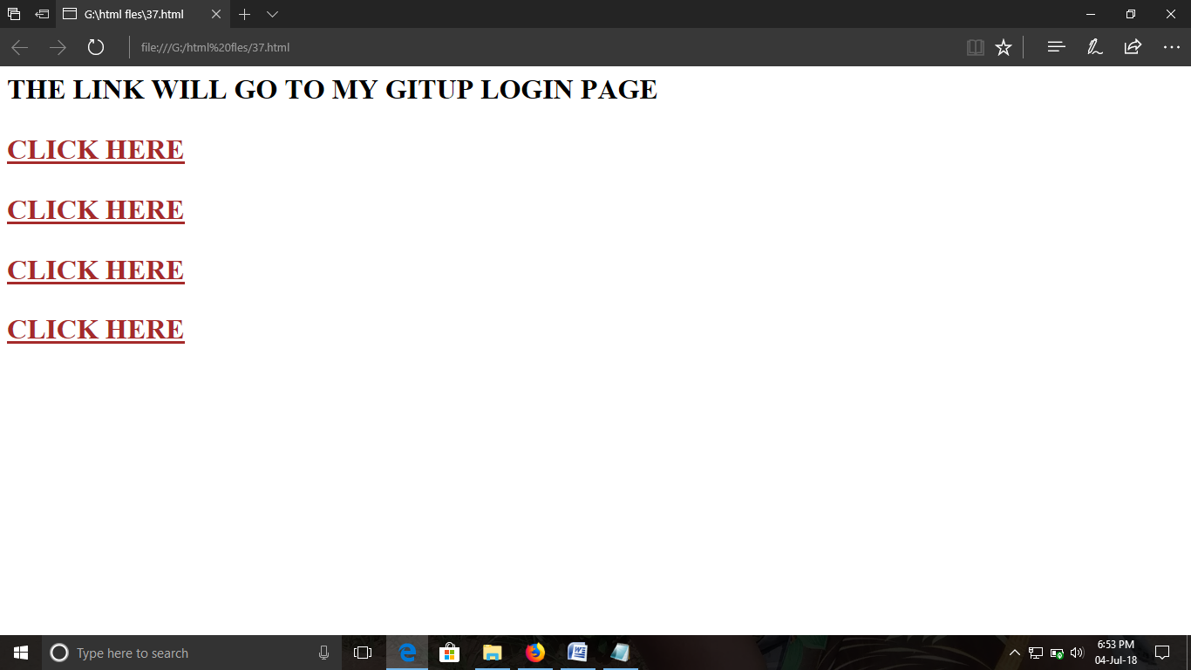

ExNo:35 /\*HTML FORMS\*/

PROGRAM:

<html>

<head>

<style>

input[type=text]

{

color:red;

}

</style>

</head>

<body>

<p><b>ENTER YOUR NAME IN THE BOX</b></p>

<form>

<label="fname">first name</label>

<input type="text" id ="fname" name="first name" placeholder="your name..">

</form>

<body>

</html>

OUTPUT:

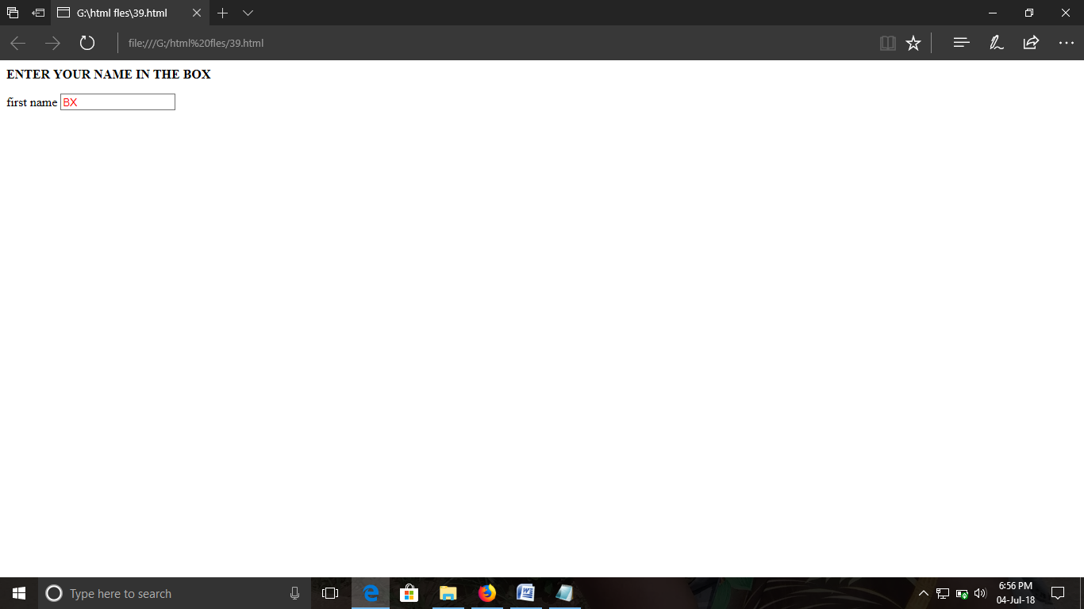

ExNo:36 /\*HTML INPUT\*/

PROGRAM:

<html>

<head>

<style>

input[type]=text

{

background-color:hotpink;

}

</style>

</head>

<body>

<p><b>ENTER YOUR INPUT VALUE</b></p>

<form>

<label ="two">name</label>

<input type="text" id="two" name="name" placehoder="your name">

<input type="submit" value="submit">

</form>

</body>

</html>

OUTPUT:

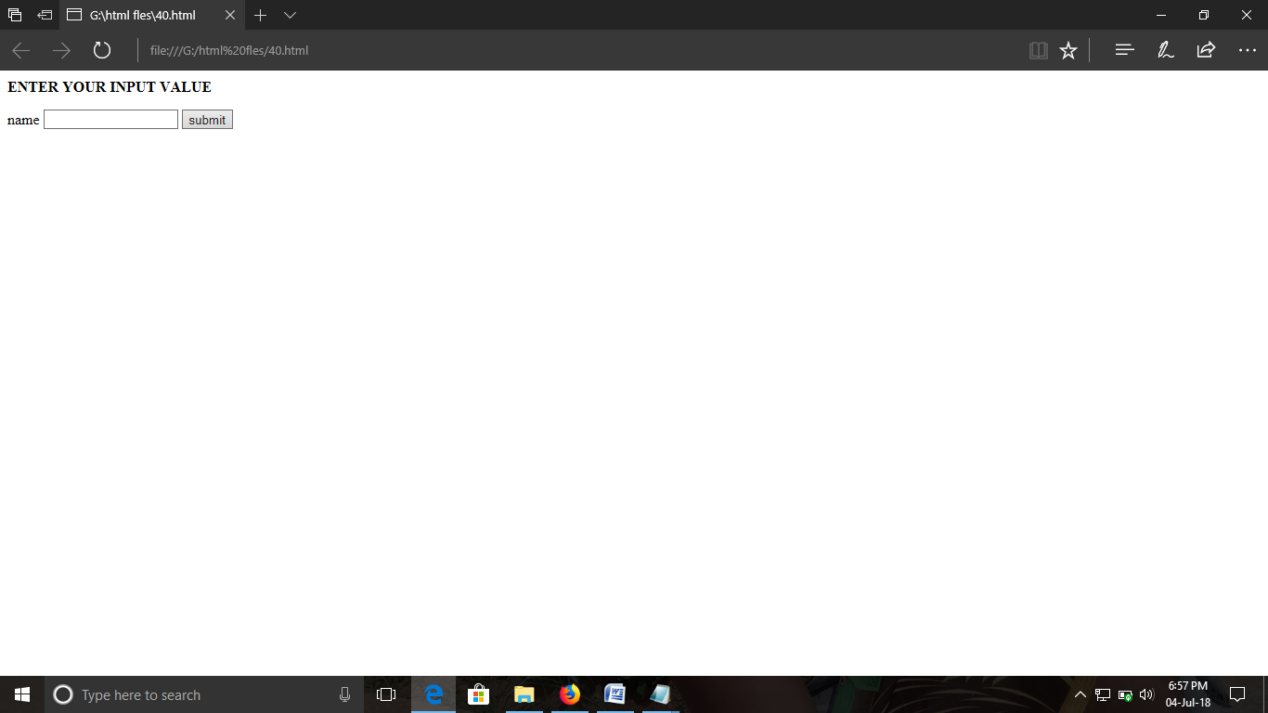

ExNo: 37 /\* HTML RESET\*/

PROGRAM:

<html>

<head>

<style>

input[type]=text

{

background-color:hotpink;

}

</style>

</head>

<body>

<p><b>ENTER YOUR INPUT VALUE</b></p>

<form>

<label ="two">name</label>

<input type="text" id="two" name="name" placehoder="your name">

<input type="reset" value="reset">

</form>

</body>

</html>

OUTPUT:

